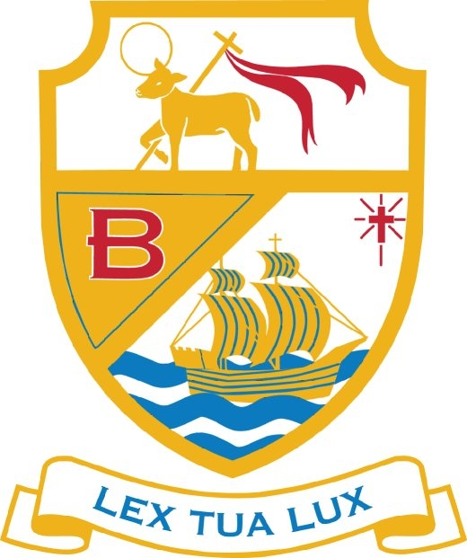**ST. BEDE’S CHS**

**LEAVER DESTINATIONS 2025**

|  |  |  |
| --- | --- | --- |
| **DESTINATION** | **NUMBER** | **%** |
| APPRENTICESHIPS (INC FOOTBALL SCHOLERSHIPS) | 12 | 8.5 |
| WINSTANLEY | 67 | 47.5 |
| RUNSHAW * | 19 | 13.5 |
| SOUTHPORT | 10 | 7.1 |
| WEST LANCS * | 2 | 1.4 |
| CITY OF LIVERPOOL | 2 | 1.4 |
| JELLIDANCE STUDIO | 1 | 0.7 |
| SJR | 7 | 4.3 |
| ROBBIE FOWLER FOOTBALL ACADEMY/6TH FORM | 4 | 2.8 |
| CARMEL COLLEGE | 1 | 0.7 |
| MYERSCOUGH COLLEGE* | 4 | 2.8 |
| KGV | 1 | 0.7 |
| HUGH BAIRD COLLEGE | 2 | 1.4 |
| WIGAN AND LEIGH COLLEGE | 1 | 0.7 |
| EVERTON COLLEGE | 3 | 2.1 |
| ORMSKIRK 6TH FORM* | 1 | 0.7 |
| HOPWOOD COLLEGE | 1 | 0.7 |
| MARINE FC Crosby | 1 | 0.7 |
| KENDAL COLLEGE | 1 | 0.7 |
| ST EDWARDS 6TH FORM | 1 | 0.7 |
| **NEET** | **0** |  |

**LANCASHIRE (*) 18.4%**

FURTHER EDUCATION 91.5%

WORK BASED LEARNING 8.5%

OTHER (NEET) 0%